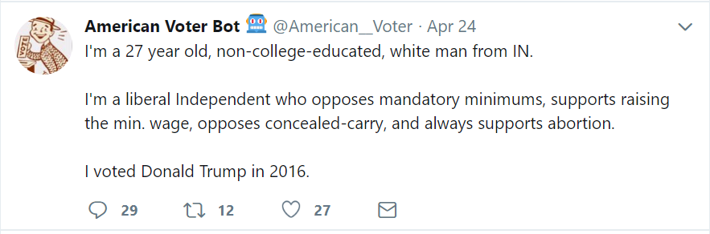

Ansolabehere, Stephen and Brian F. Scha_ner, COOPERATIVE CONGRESSIONAL ELECTION STUDY, 2016: COMMON CONTENT. [Computer File] Release 2: August 4, 2017. Cambridge, MA: Harvard University [producer] <http://cces.gov.harvard.edu>

N = 64,000

Conducted in two waves, pre and post election

Post election questions all have at most 52899 respondents

There are five parts to the 2016

CCES Common Content { sample identi_ers (including state and congressional district),

profile questions (largely demographic), pre-election questions, post-election questions, and

contextual data (including candidate names and parties, election results, and roll call votes).

All counts are unweighted, raw counts. The tables distinguish between subtypes of missing

data: missing due to respondent skipping and missing due to the question not being asked to

the respondent (e.g. due to branching), although some inaccurate labeling within the missing

data category may exist. Please consult the questionnaire to see the branching structure of

the questions asked.

Questions that most respondents were not asked:

Multrace_*

Hispanic origin

Hadjob

Phone (most skipped)

Relig-pew_protestant

Birthyr is missing, fortunately I can join on the cumulative CCES data…